**GIT ASSIGNMENT 1**

1.Create a directory ‘project_dir’ & cd to ‘project_dir’.

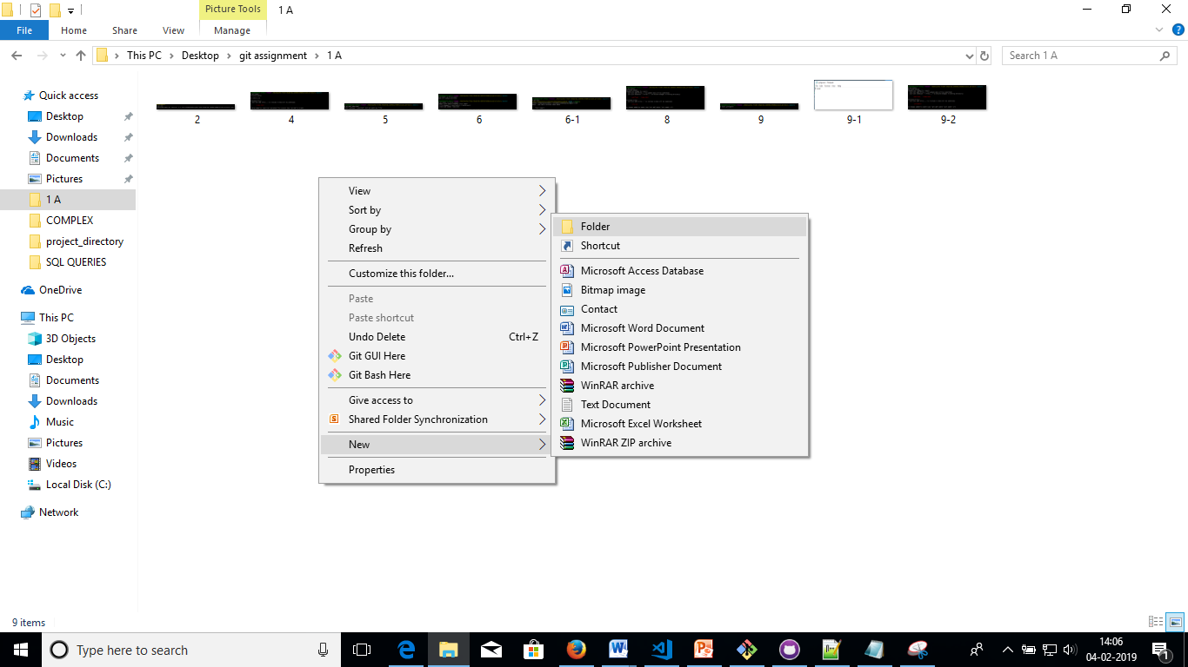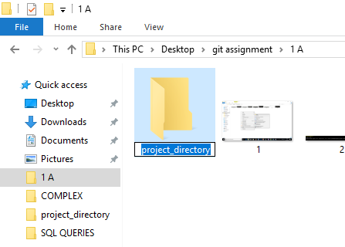

2.Initialize git version database. (git init)

C:\Users\BNB000\Downloads\ssql\git\git1.PNG

3.Create a new file index.html.

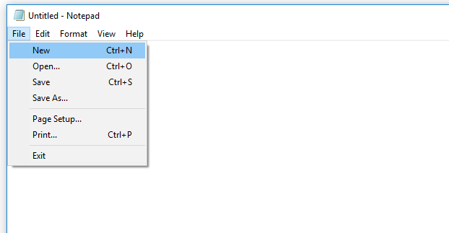

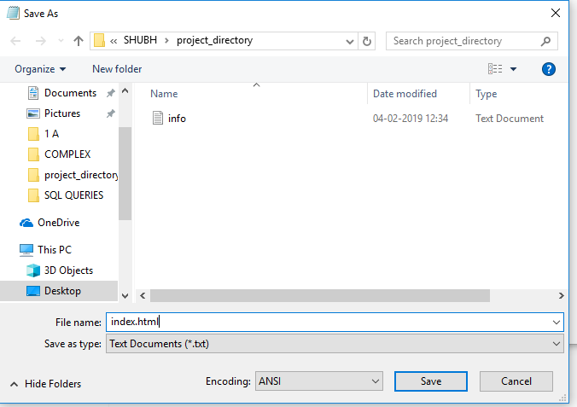

4.Check the git status. You should find index.html as untracked file.

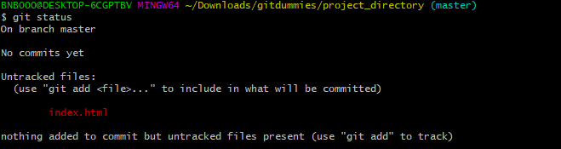

5.Stage the index.html file.

C:\Users\BNB000\Downloads\ssql\git\git5.PNG

6.Commit index.html

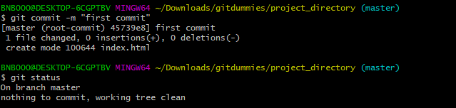

7.Make few changes in index.html & create a new file info.txt file.

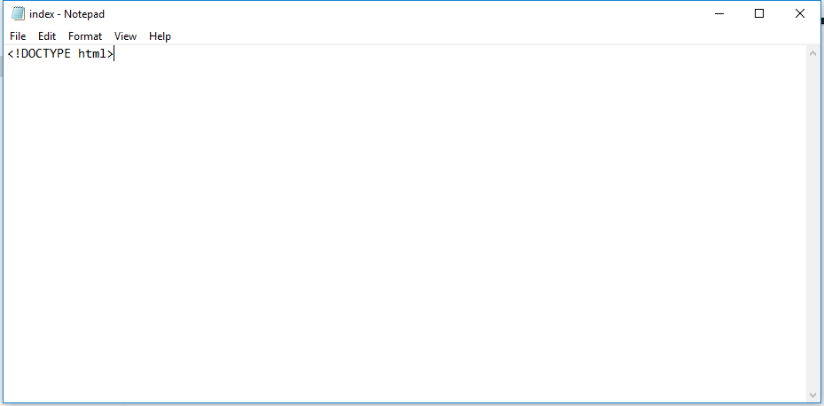

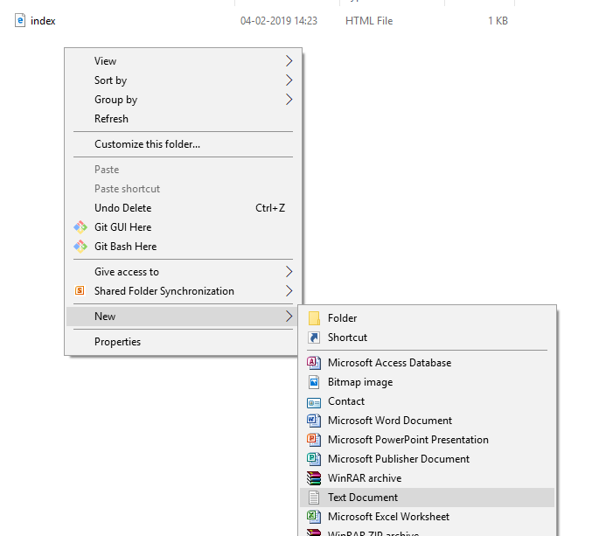

8.Check git status. You should find index.html & info.txt as untracked files.

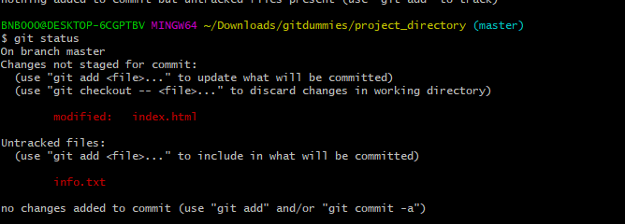

9.Configure GIT to ignore all txt files.

C:\Users\OYA000\Desktop\git assignment\1 A\9.PNG

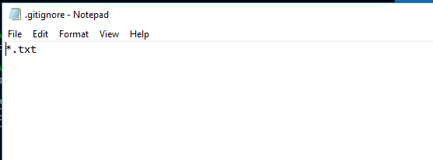

10.Again check the git status. You should find only index.html as untracked file.

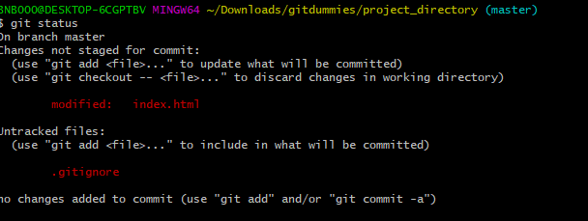

11.State & commit index.html



12.Log all your comments so far.

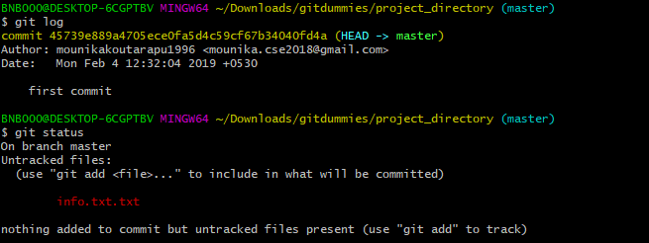

13.Make some changes in index.html.

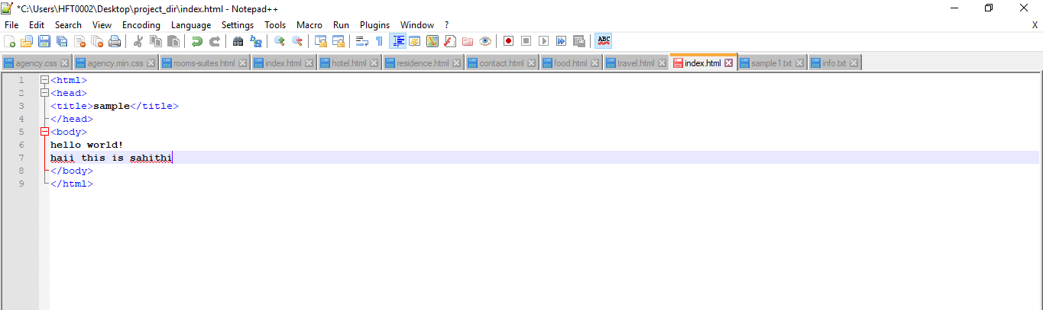

14.Revert the change made in the previous step using git command.



15.Again change index.html.

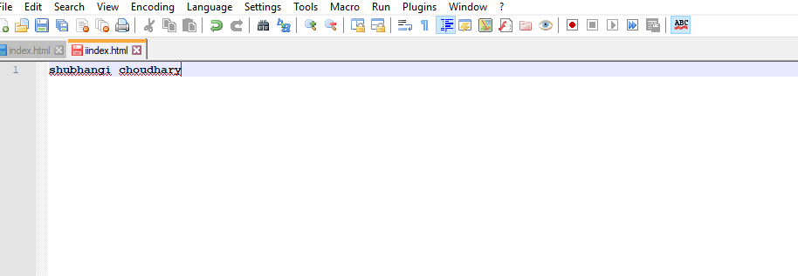

16.Stage index.html

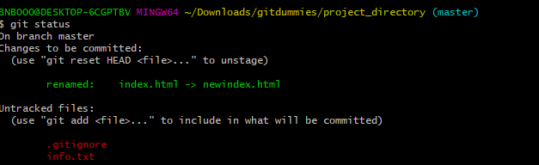

17.Revert back the last stage.

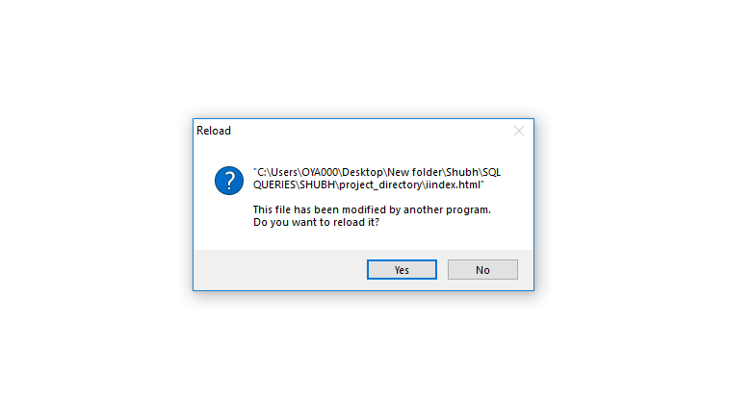



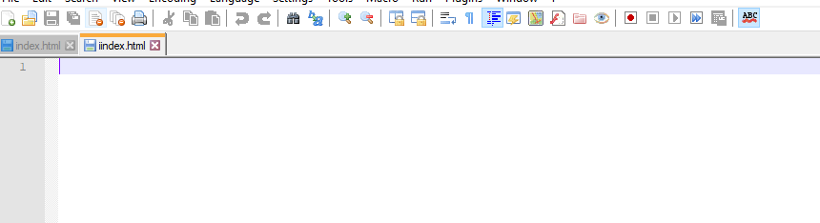

18.Rename ‘add’ command to ‘my-add’.

C:\Users\OYA000\Desktop\git assignment\1 A\18-1.PNG

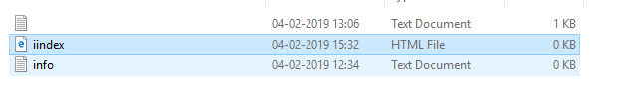



19.Using my_add command Stage index.html again & commit the changes.

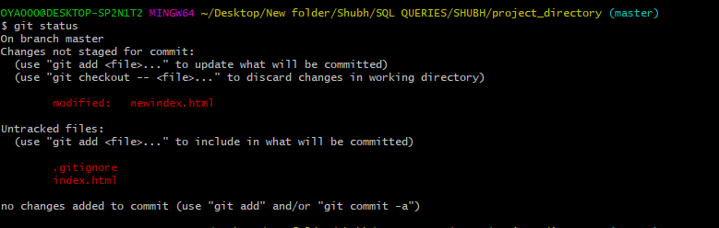

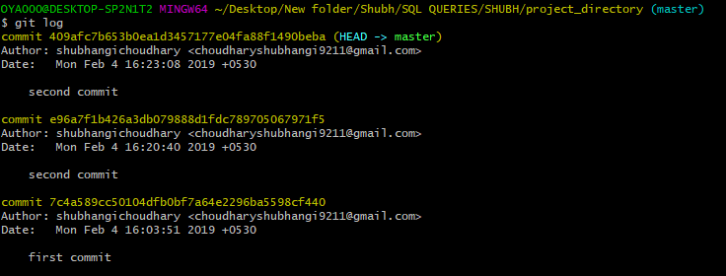

20.Revert the last commit.

C:\Users\OYA000\Desktop\git assignment\1 A\20.PNG